- TITLE PAGE

SME BUSINESS MANAGEMENT SYSTEM

Registration Number: COM/0043/23

Course: Bachelor of Science in Computer Science

Unit Code: CSC 3250 – Software Project I

Institution: KIBABII UNIVERSITY

Date of Submission: April 2026

- ABSTRACT

This project presents the development of a Small and Medium Enterprise (SME) Business Management System designed to improve the efficiency of managing business operations such as sales tracking, expense recording, product management and profit calculation.

Many small business owners rely on manual record-keeping methods which are prone to errors, data loss and inefficiency. This system provides a digital solution that automates these processes, enabling accurate and real-time monitoring of business performance.

The system was developed using Python with the Flask framework for the backend, SQLite for the database and HTML, CSS and JavaScript for the frontend interface. It incorporates user authentication using Flask-Login, role-based access control and features such as product management, sales recording, expense tracking and automated profit calculation.

The system enhances decision-making by providing summarized dashboards and sales visualization charts. It also improves data security and accessibility compared to traditional manual systems.

Overall, the project demonstrates how simple web technologies can be used to build a practical and scalable solution for small businesses, improving operational efficiency and financial tracking.

- INTRODUCTION
  - Background of the Study

Small and Medium Enterprises (SMEs) play a crucial role in economic development by providing employment and supporting local economies. However, many SMEs still rely on manual methods such as notebooks to record sales, expenses and stock levels.

These manual systems are inefficient, prone to human error and make it difficult to track business performance accurately. In addition, they do not provide real-time insights, making decision-making slow and unreliable.

With the advancement of technology, digital systems offer an opportunity to automate these processes, ensuring accuracy, efficiency and better data management. This project aims to develop a web-based SME system that simplifies business operations and enhances financial tracking.

  - Problem Statement
Many small business owners face challenges in managing their daily operations due to reliance on manual record-keeping systems. These challenges include:

- Loss of business records
- Errors in calculating profit
- Lack of real-time data insights
- Poor tracking of expenses and sales
- Difficulty in managing multiple users

These limitations reduce business efficiency and can lead to financial losses.

  - Objectives
General Objective

To develop a web-based SME Business Management System that improves the efficiency of managing sales, expenses, and profit calculation.

Specific Objectives
- To design a system for recording and managing products
- To implement sales tracking functionality
- To automate profit calculation (Sales – Expenses)
- To implement role-based access (Admin and Staff)
- To provide a dashboard for business insights

  - Scope of the System

The system focuses on small business operations including:

- Product management
- Sales recording
- Expense tracking
- Profit calculation
- User role management

The system is web-based and designed for use on computers or smartphones with internet access. It does not include advanced features such as mobile payments or real-time tracking at this stage.
- LITERATURE REVIEW
  - Introduction
This chapter reviews existing systems and technologies related to business management systems. It focuses on how current solutions manage sales, inventory and financial records, and identifies gaps that justify the development of the proposed SME Business Management System.

  - Existing Systems
Various systems have been developed to assist businesses in managing operations. These include Point of Sale (POS) systems, inventory management systems and accounting software.

Point of Sale systems are commonly used in supermarkets and retail shops to record sales transactions and manage inventory in real time. Examples include systems used in large retail chains where barcode scanning and automated billing are implemented.

Inventory management systems focus on tracking stock levels, product movement and reordering processes. These systems help prevent stock shortages and overstocking.

Accounting systems such as QuickBooks and Sage are used to manage financial records, including expenses, revenues and profit calculations. These systems provide detailed financial reports and analytics.

Despite their effectiveness, most of these systems are designed for medium to large enterprises and may be complex or expensive for small businesses.

  - Technologies Used in Existing Systems
Modern business management systems use a variety of technologies to enhance performance and accessibility.

Web-based systems are widely used because they can be accessed from any device with an internet connection. These systems use backend frameworks such as Flask, Django or Node.js and frontend technologies like HTML, CSS and JavaScript.

Database systems such as MySQL, PostgreSQL and SQLite are used to store and manage data efficiently.

Cloud computing is also commonly used to enable data storage and access over the internet, improving scalability and reliability.

Authentication technologies such as Flask-Login and OAuth are used to ensure secure access to systems.

  - Gaps in Existing Systems
Although many systems exist, several gaps still affect small business adoption:

- High cost of implementation and maintenance
- Complexity in usage, especially for non-technical users
- Lack of customization for small businesses
- Dependence on constant internet connectivity
- Limited accessibility in rural areas with poor infrastructure

Additionally, many systems focus heavily on advanced features while ignoring simplicity and usability, which are critical for SMEs.

  - Justification of the Proposed System
The proposed SME Business Management System aims to address the identified gaps by providing a simple, cost-effective and user-friendly solution.

The system is designed specifically for small businesses, focusing on essential features such as sales tracking, expense management and profit calculation. It uses lightweight technologies such as Flask and SQLite, making it easy to deploy and maintain.

Unlike complex enterprise systems, this system prioritizes simplicity and accessibility while still providing meaningful insights through dashboards and analytics.

Furthermore, the system introduces role-based access control, ensuring that sensitive financial data is restricted to administrators while staff handle operational tasks.

- SYSTEM ANALYSIS
  - Introduction
System analysis involves studying the existing system, identifying its weaknesses and defining the requirements for the proposed system. This chapter explains the current manual system used by small businesses and the proposed digital solution.

  - Current System (Manual System)
The current system used by many small businesses is manual. Business owners record transactions such as sales, expenses and stock levels in notebooks or paper records.

Sales are recorded by writing down the product name, quantity sold, and total amount. Expenses are also recorded separately and profit is calculated manually by subtracting expenses from total sales.

This method is simple but has several limitations.

Problems with the Current System
The manual system presents several challenges:

- Errors in calculations due to human mistakes
- Loss or damage of records
- Difficulty in tracking daily or monthly performance
- No real-time data access
- Time-consuming processes
- Lack of accountability among staff

These issues reduce efficiency and make it difficult for business owners to make informed decisions.

  - Proposed System
The proposed system is a web-based SME Business Management System that automates business operations.

The system allows users to manage products, record sales, track expenses and automatically calculate profit. It also provides a dashboard that displays key business metrics such as total sales, expenses and profit.

The system introduces role-based access control, where administrators have full control of the system while staff are limited to operational tasks such as recording sales.

  - Functional Requirements
Functional requirements describe what the system should do.

The system should:

- Allow users to register and log in securely
- Allow the admin to manage users (add, delete, change roles)
- Allow users to add, update and delete products
- Allow staff to record sales transactions
- Allow the admin to record and manage expenses
- Automatically calculate profit (Sales – Expenses)
- Display dashboard statistics and charts
- Provide sales history and reports

  - Non-Functional Requirements
Non-functional requirements describe how the system should perform.

- Performance: The system should respond quickly to user actions
- Security: User passwords should be encrypted and protected
- Usability: The interface should be simple and user-friendly
- Reliability: The system should produce accurate results consistently
- Scalability: The system should support additional users and data

  - Feasibility Study
Technical Feasibility
The system is technically feasible because it uses widely available technologies such as Python, Flask and SQLite. These tools are lightweight and easy to implement.

Economic Feasibility
The system is cost-effective since it uses open-source technologies and does not require expensive hardware or software.

Operational Feasibility
The system is easy to use and can be adopted by small business owners with minimal training.

- SYSTEM DESIGN
  - Introduction
System design defines the structure, components, and architecture of the SME Management System. It describes how different parts of the system interact to achieve the desired functionality.

The system is designed to be simple, efficient and user-friendly while ensuring accurate business data management.

  - System Architecture
The system follows a three-tier architecture consisting of:

1. Presentation Layer (Frontend)
- Interface seen by users (HTML, CSS, JavaScript)

2. Application Layer (Backend)
- Handles logic using Flask (Python)

3. Data Layer (Database)
- Stores data using SQLite

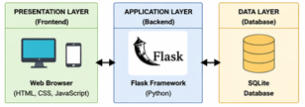

Figure 6.1: System Architecture Diagram

  - UML DIAGRAMS

Use Case Diagram

The use case diagram shows how users interact with the system.

There are two actors:

- Admin

- Staff

Admin can:

- Manage users

- Manage products

- Manage expenses

- View reports

Staff can:

- Record sales

- View dashboard

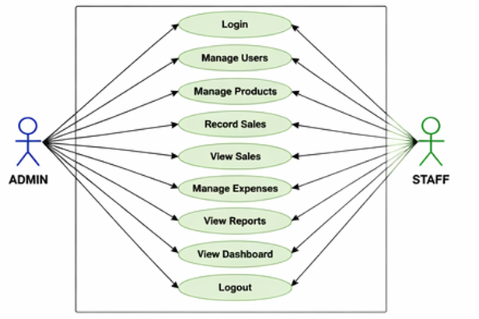

Figure 6.2: Use Case Diagram
    - Class Diagram

The class diagram represents the system structure.

Main classes:
- User (id, username, password, role)
- Product (id, name, buying_price, selling_price, quantity)
- Sale (id, product_id, quantity, total_amount, profit, date)
- Expense (id, description, amount, date)

Relationships:
- A user performs sales
- A product is linked to sales
- Expenses affect profit calculation

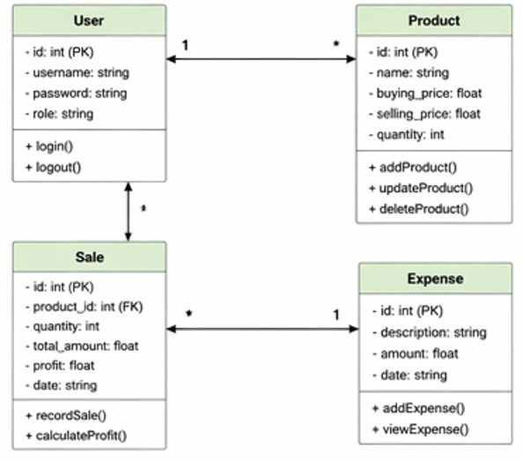

Figure 6.3: Class Diagram

Sequence Diagram (Record Sale)

This diagram shows the process of recording a sale.

Steps:

1. Staff enters sale details

2. System validates input

3. Data is sent to backend

4. Saved in database

5. Confirmation is returned

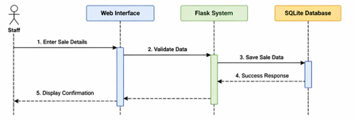

Figure 6.4: Sequence Diagram
  - Database Design
The system uses SQLite database with the following tables:

1. users
- id
- username
- password
- role

2. products
- id
- name
- buying_price
- selling_price
- quantity

3. sales
- id
- product_id
- quantity
- total_amount
- profit
- date

4. expenses
- id
- description
- amount
- date

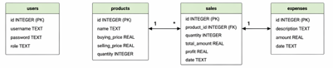

Figure 6.5: Database Design (ER Diagram)

  - User Interface Design (UI Mockups)
The system interface is designed to be simple and user-friendly.

Key screens include:
- Login Page
- Dashboard
- Products Page
- Sales Page
- Expenses Page
- User Management Page

The dashboard provides quick insights into business performance through statistics and charts.

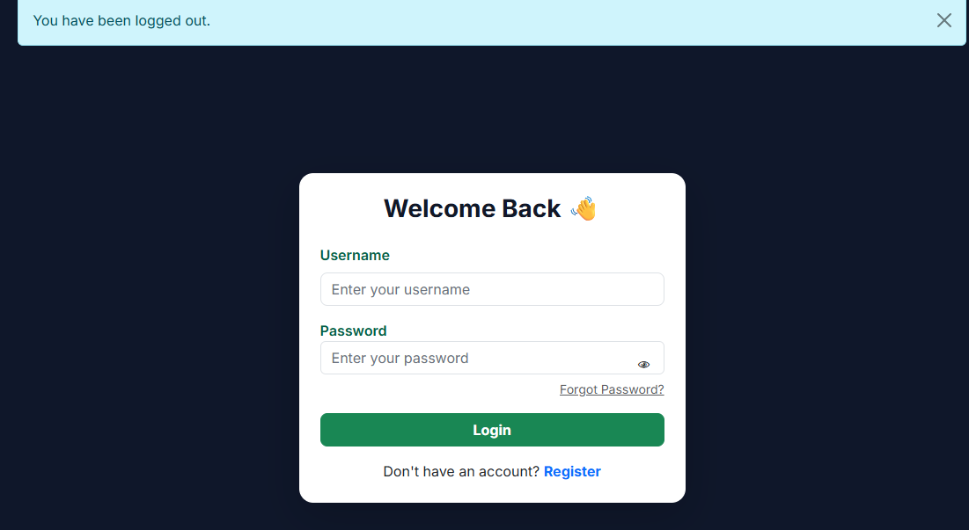

Login Page
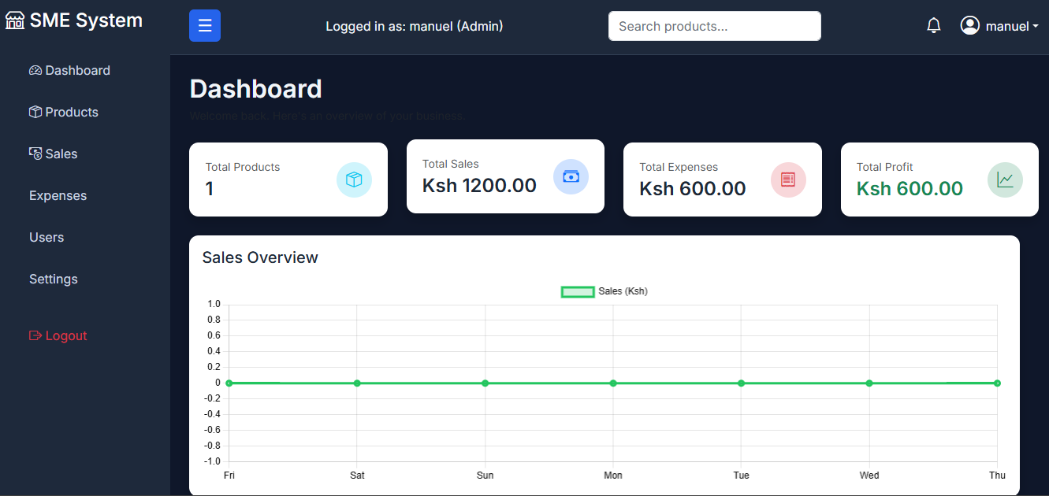
Dashboard

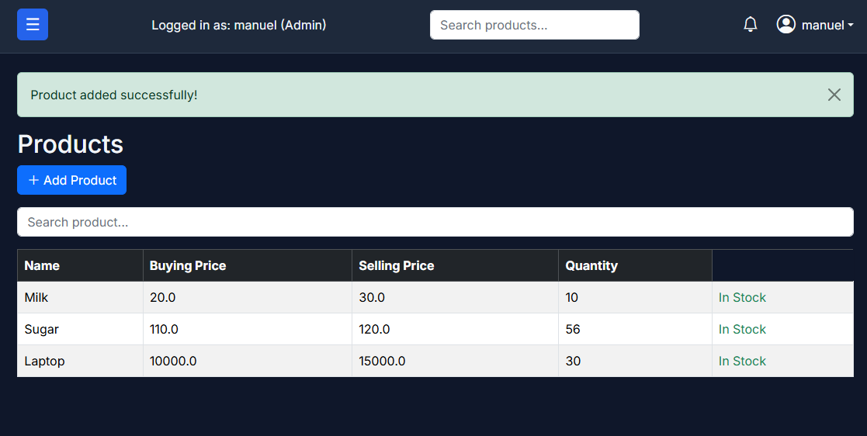
Products

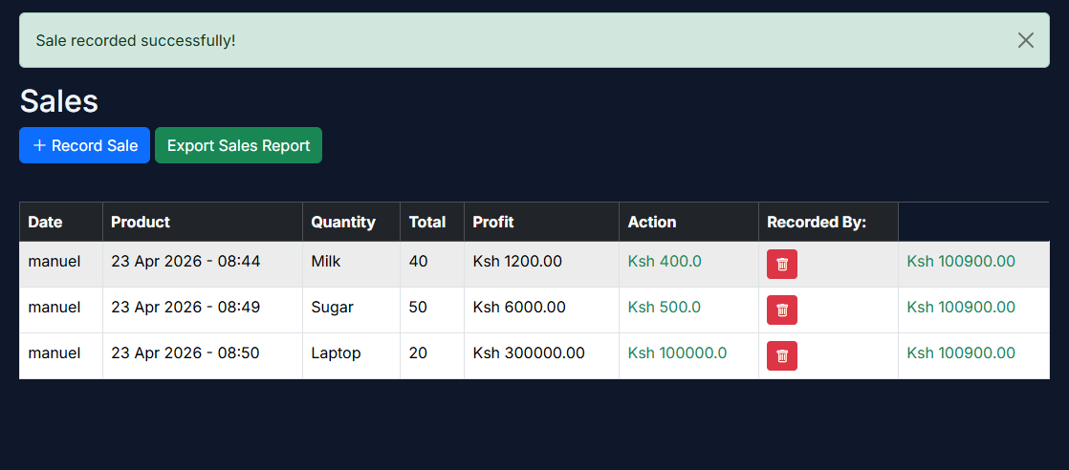
Sales

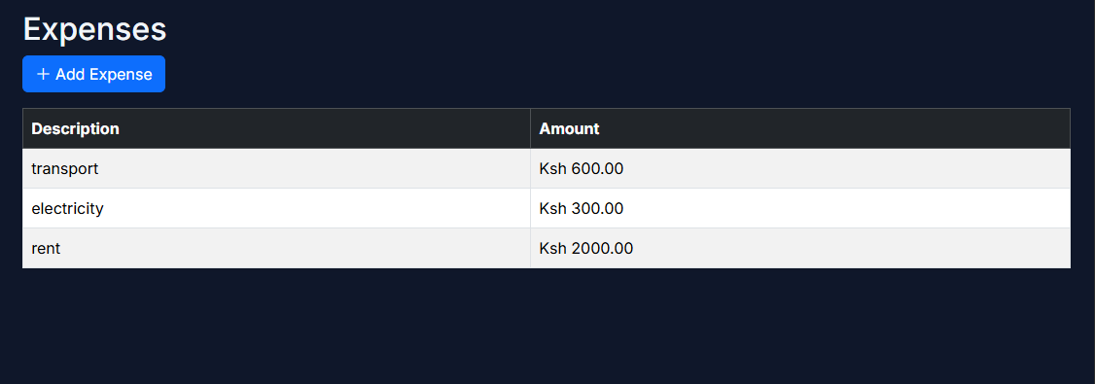

Expenses

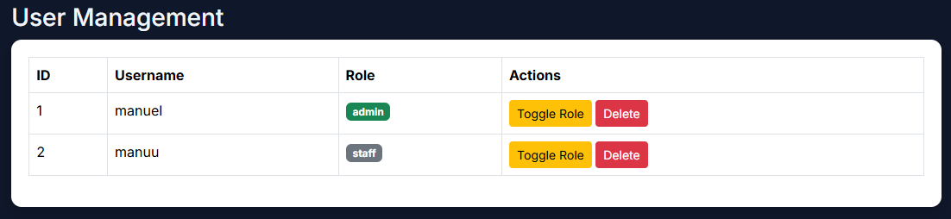
Users

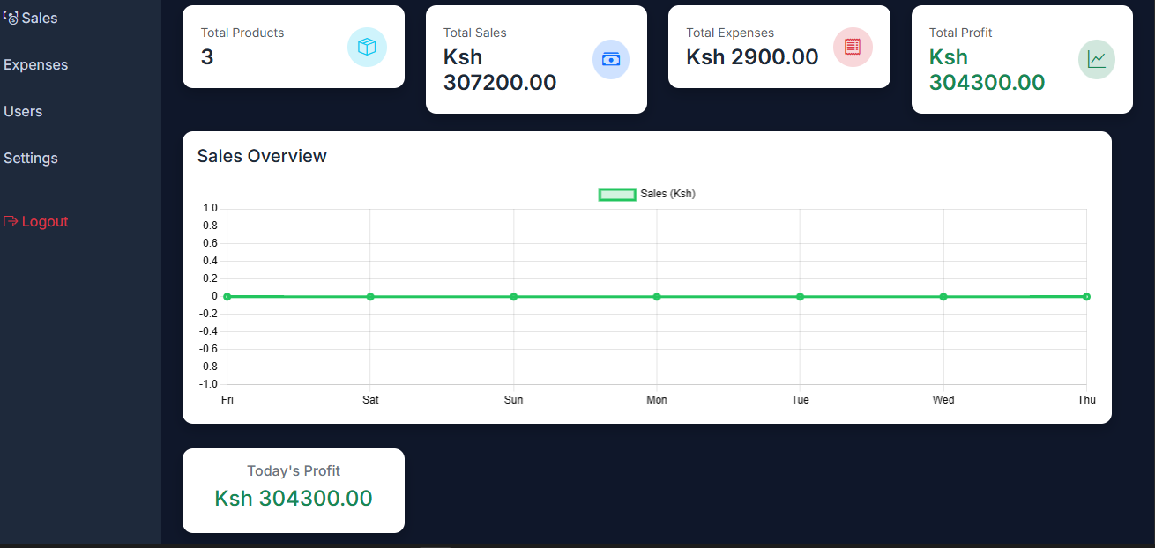
Figure 6.6: Dashboard Interface

